1. <https://www.youtube.com/watch?v=lwqfVLfBn4s>
2. 
3. 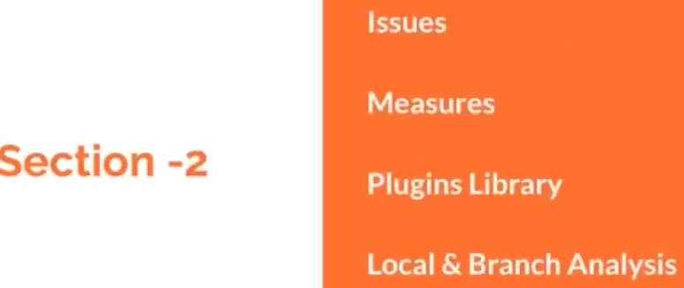
4. 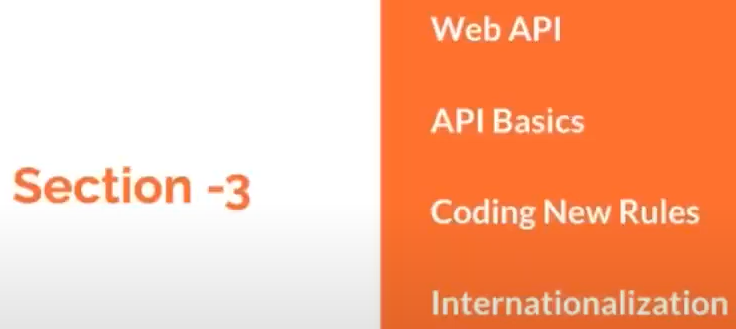
5. 
6. No matter who you’re either Software Developer, Tester, Project Manager, Administrator, you have some responsibility in some way in order to make the quality of a software to deliver to the customer. Otherwise you can’t survive in a job.
7. For quality check, a developer has to make sure the following things:
   1. Running a lot of test cases (Unit Testing, Integration Testing).
   2. Code Coverage.
   3. Running a lot of plug-ins for the followings:
      1. To check for any bugs.
      2. Any vulnerability is exposed.
      3. Any Cross Site Scripting is exposed.
      4. SQL Injection.
8. Then that code is assigned to Team Lead and then to Project Manager and then to Customer.
9. 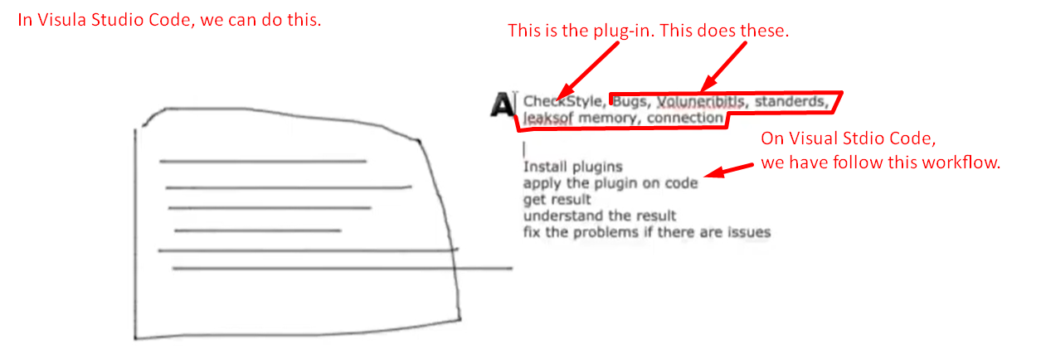
10. 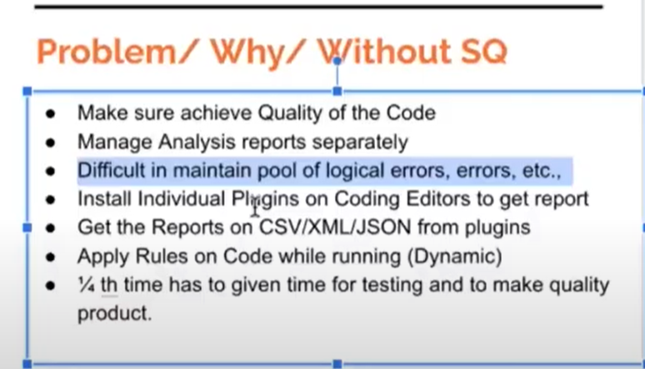
11. 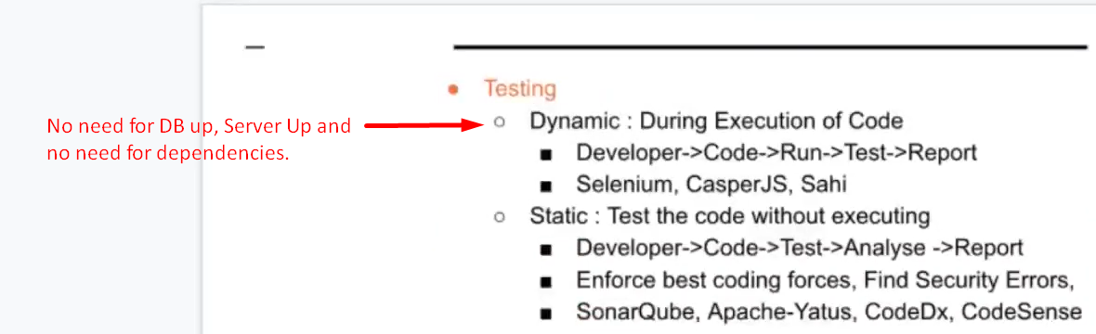
12. 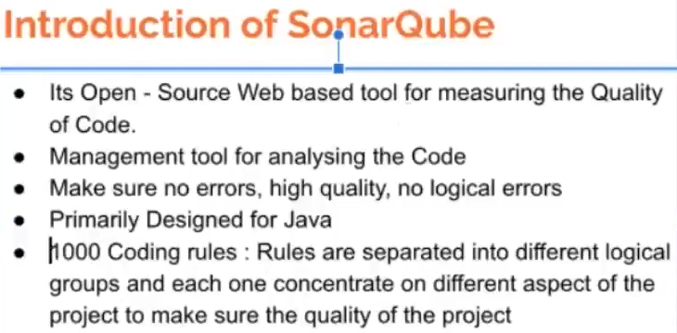
13. 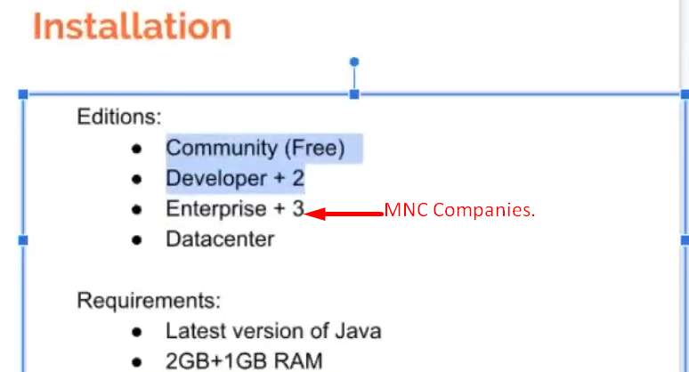
14. 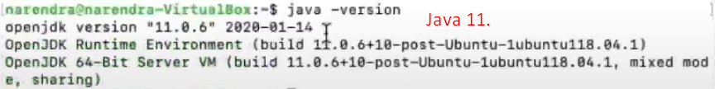
15. 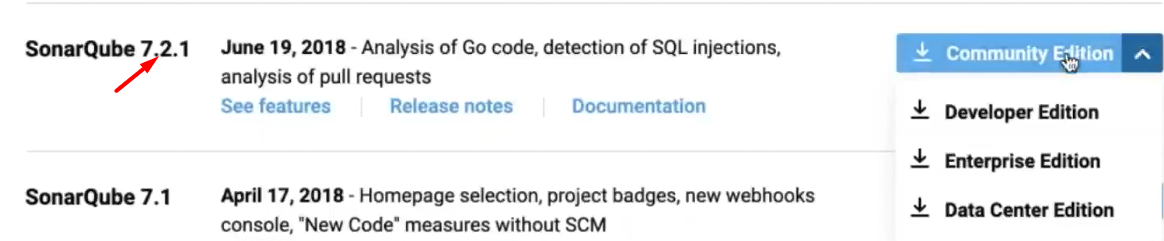
16. 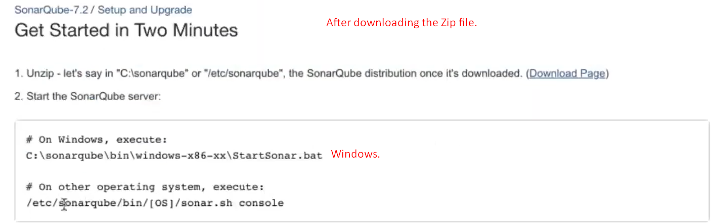
17. 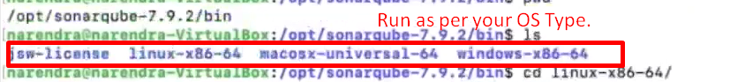
18. 
19. 
20. 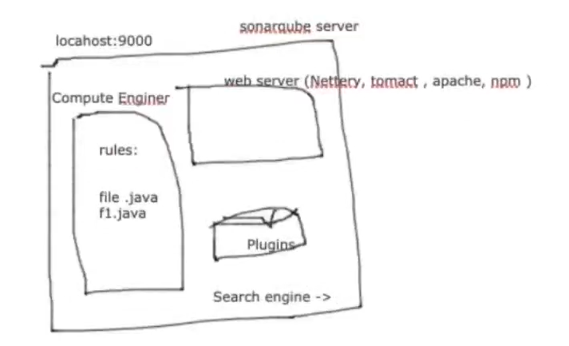
21. 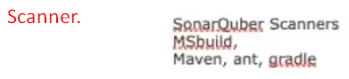
22. 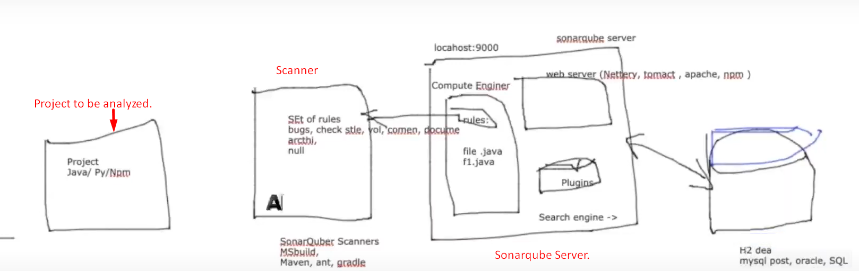
23. 
24. 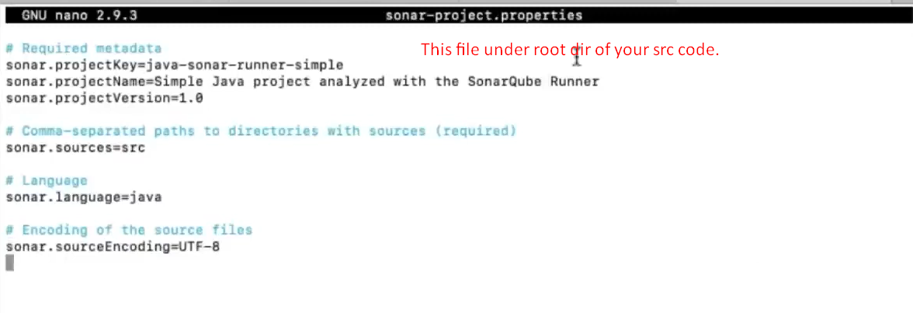
25. 
26. 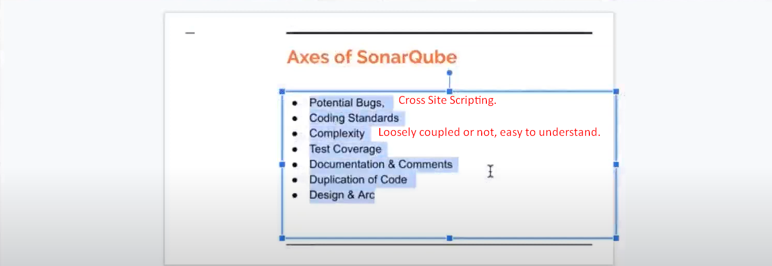
27. Code Debt: Total Time to be taken to solve issue/issues.